# OPTIMIZING FLIGHT BOOKING DECISIONS THROUGH MACHINE LEARNING PRICE PREDICTIONS

**Project Based Experiential Learning Program**

**OPTIMIZING FLIGHT BOOKING DECISIONS THROUGH MACHINE**

**LEARNING**

**SUBMITTED BY**

**S.DEEPIKA(20445ER001)**

**M.NANDHINI(20445ER004)**

**V.SHENBAGAPRIYA(20445ER007)**

**G.VISHNU VARTHINI(20445ER009)**

**M.PANDEESWARI(**

UNDER THE GUIDANCE OF

MRS.S.EZILARASI KUMARAVEL

**DEPARTMENT OF COMPUTER SCIENCE**

**GOVERNMENT ARTS AND SCIENCE COLLEGE FOR WOMEN**

**KODAIKANAL-624101**

**APRIL-2023**

**CONTENT**

**1 INTRODUCTION**

1.1 OVERVIEW

1.2 PURPOSE .

THE USE OF THIS PROJECT

**2 PROBLEM DEFINITION AND DESIGN THINKING**

2.1 EMPATHY MAP

2.2 IDEATION AND BRAINSTORMING MAP

**3 RESULT FINAL FINDINGS (OUTPUT)**

**4 ADVANTAGES & DISADVANTAGES**

**5 APPLICATIONS**

**6 CONCLUSION**

CONCLUSION SUMMARIZING THE ENTIRE WORK

**7 FUTURE SCOPE**

**8 APPENDIX**

SOURCE CODE

**1.INTRODUCTION**

In today’s airline industry users or customers can reserve seat or book flight from any place

in the world as long as they are connected to internet. The Innovation of technology has

made traveling in the air easier for customers with airline reservation or booking just a click away.

The fastest means of transportation today is by air. Thousands of people flock the airline

industry this days so that they can arrive their destination within a short period of time.

Airline reservation systems incorporate airline schedules, fare tariffs, passenger reservation

and ticket records. An airline’s direct distribution works within their own reservation

system, as well as pushing out information to the GDS . The second type of direct

distribution channel are consumers who use the internet or mobile applications to make

their own reservations. Travel agencies and other indirect distribution channels access the

same GDS as those accessed by the airline reservation systems, and all messaging is

transmitted by a standardized messaging system that functions on two types of messaging

that transmit on SITA’s high level network (HLN) .

These messaging types are called type A [usually EDIFACT format] for real time interactive

communication and type of messages. Message construction standards set by IATA and

ICAO ,are global, and apply to more than air transportation. Since airline reservation

systems are business critical applications, and they are functionally quite complex, the

operation of an in-house airline reservation system is relatively expensive.

* 1. **OVERVIEW**

The Airline Reservation system project is an implementation of a general Airline Ticketing

website like Orbitz , which helps the customers to search the availability of flights, book

and cancel the flight tickets. This project also covers adding ,deleting or modifying the

customers details and flights . In general, this website would be designed to perform like

any other airline ticketing website available online.

* 1. **PURPOSE**

The purpose of this project is to implement or to design a database for an airline reservation

system to check the flight details ,book and cancel flight tickets. It makes the process of

booking and cancelling flight tickets simple and easy for the passengers.

**2.PROBLEM DEFINITION AND DESIGN THINKING**

Normally a person wants to reserve his ticket and he has to contact at nearest Overseas

Travels branch. The Airline Reservation system provides an interface to schedule flight and

reservations for an airline through internet. ITS responsibility is to keep track of system

users, customers, Airbus information, flight information and cancellation.

**2.1.EMPATHY MAP**

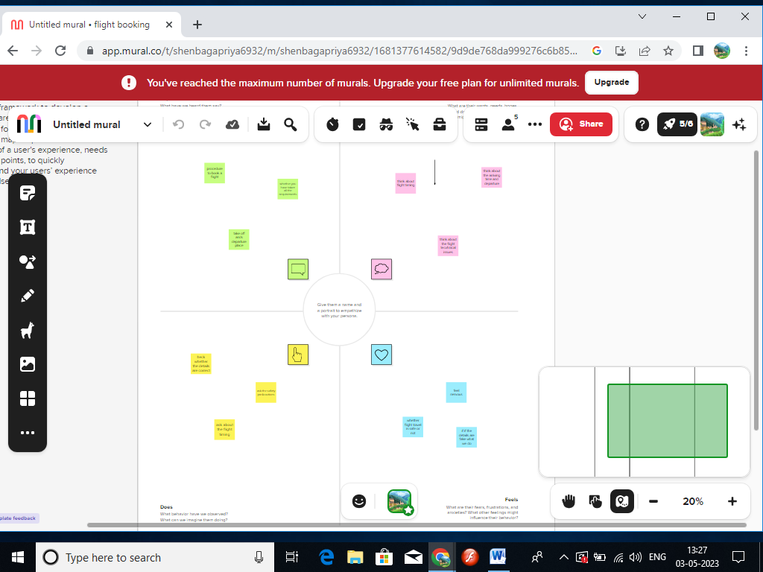

**GITHUB SCREENSHOT**

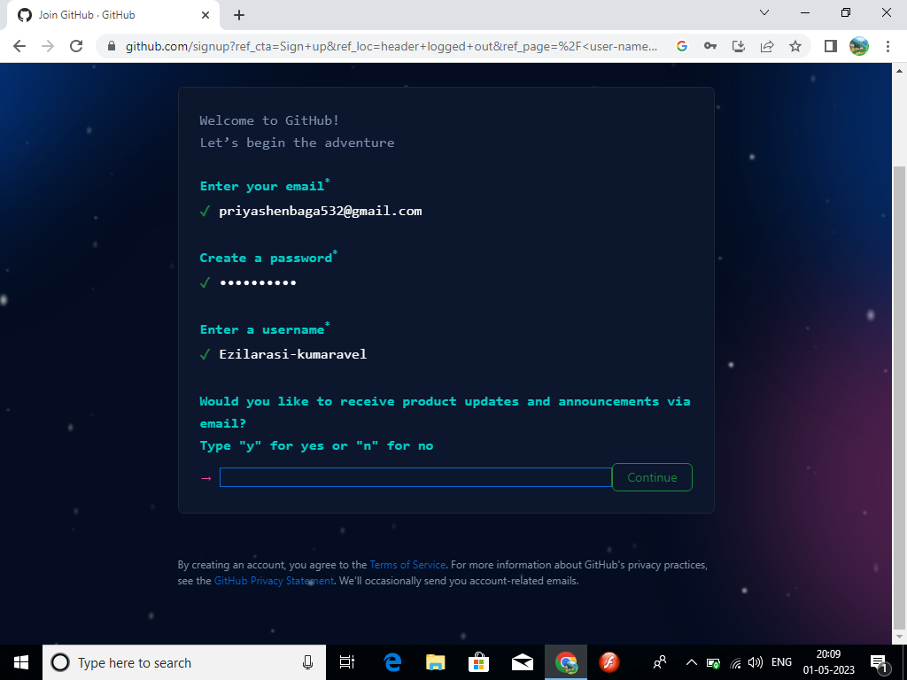

**4. ADVANTAGES AND DISADVANTAGES**

**ADVANTAGES OF PROPOSED SYSTEM**.

* The proposed system due to computerized is much faster in reservation process

,cancellation process and transactions.

* Transfer of information from various branches would become easier and faster.
* Managing and maintaining data becomes easier and cost effective due to very high

amountand reliability of storage space available in the proposed system.

* Customer services can not only be satisfied but also enhanced to the extent that one can obtain or cancel a reservation from any given time.

**DISADVANTAGES**

* Online booking is likely only a problem if your business routinely operates without internet access.
* In this case, you’ll want to be prepared ahead of time and plan accordingly so you have adequate staffing and resources in place for a busy season.
* A poorly designed reservation system could even create the disadvantage of poor customer service if guests can’t book easily.
* So, it’s important to take the time to choose your provider carefully.

**5. APPLICATIONS**

Flight booking systems software maintains customers information in case of emergency.

The flight companies will use this profile to track user choice and travel patterns to serve

them better ,plan routes, for better marketing and effectives scheduling of flights.

A flight management system project in python is a multi-purpose on-board navigation,

performance and aircraft operations computer that provides virtual data and operational

harmony between closed and open aspects connected with a flight from pre engine start

and take -off to landing and engine shut-down.

**6.CONCLUSION**

The Airline booking system has a way of minimizing the clerical work , which is almost a

routine and consumes the most precious time. This Airline booking system has been an

attempt to help the user to minimize his workload along with minimizing the paper works

and saving of time. The system has been developed in a way to make it very user friendly .It

provides an on-line message and an error detection and error messages every time the user

needs. Any person having a little bit of window based can run this system without any pain .

As a future enhancement we have decided to further enhance with a seat booking

available. It is to fulfill passengers request to sit where they prefer . They are allowed to

choose their seat whether near to window’s seat or in the middle.

**7.FUTURE SCOPE**

It may help collecting perfect management in details.In a very short time,the collection will

be obvious,simple and sensible. It will help a person to know the management of passed

year perfectly and vividly.

* In computer system the person has to fill the various forms & number of copies of the
* formscan be easily generated at a time.
* In computer system,it is not necessary to create the manifest but we can directly

print it , which saves our time.

* To assist the staff in capturing the effort spent on their respective working areas.
* To utilize resources in an efficient manner by increasing their productivity through
  + automation.
  + The system generates types of information that can be used for various purpose.
  + It satisfy the user requirement.
  + Be easy to understand by the user and operator.
  + Be easy to operate
  + Have a good user interface
  + Be expandable
  + Delivered on schedule within the budget.

**SOURCE CODE**

import *

from tkinter.messagebox import *

import sqlite3

root=Tk()

root.title("intro")

con=sqlite3.Connection('flight_db')

cur=con.cursor()

cur.execute("create table if not exists airlines(user_name varchar(20) primary key,first_name varchar(20),last_name varchar(20),phone_number number(10),email varchar(30),passw varchar(20))")

fr2=Frame()

fr2.pack(side=LEFT,expan

def airline():

root.destroy()

root1=Tk()

root1.title("Booking Portal")

b=PhotoImage(file="airoplane.gif")

Label(root1,image=b).grid(row=0,column=0,columnspan=4)

Label(root1,text="Welcome to Airline Booking System",font=("Bauhaus 93",17),fg="Red",width=46,bg="White").grid(row=0,column=0,columnspan=4)

Label(root1,text="Flights Availability",font=("Bauhaus 93",17),fg="White",width=46,bg="red").grid(row=1,column=0,columnspan=4)

Label(root1,text="Select Pick Up Point",font=("Bauhaus 93",14),fg="Blue").grid(row=2,column=1)

variable = StringVar(root1)

variable.set("Select Source") # default value

w = OptionMenu(root1, variable, "Delhi", "Kolkata", "Mumbai","U.S.A","Canada")

w.grid(row=2,column=2)

Label(root1,text="Select Boarding Point",font=("Bauhaus 93",14),fg="Blue").grid(row=3,column=1)

variable1 = StringVar(root1)

variable1.set("Select Destination") # default value

w = OptionMenu(root1, variable1, "Delhi", "Kolkata", "Mumbai","U.S.A","Canada")

w.grid(row=3,column=2)

#Sign In

def signup():

def success():

user = user_name.get()

cur.execute("select user_name from airlines where user_name=(?)", (user,))

a = cur.fetchall()

if a != []:

showerror('Error',"Username Already Exists")

else:

l = (user_name.get(), first_name.get(), last_name.get(),phone_number.get(),email.get(), passw.get())

cur.execute("insert into airlines values(?,?,?,?,?,?)",l)

showinfo('Signed Up',"Congratulation You are Successfully Signed Up")

con.commit()

user_name.delete(0,20)

first_name.delete(0,20)

last_name.delete(0,20)

phone_number.delete(0,10)

email.delete(0,30)

passw.delete(0,20)

root1.destroy()

root=Tk()

root.title("Sign Up")

d=PhotoImage(file="airoplane.gif")

Label(root,image=d).grid(row=0,column=0,columnspan=4)

Label(root,text="Welcome to Airline Booking Systems",font=("Bauhaus 93",17),fg="Red",width=46,bg="White").grid(row=0,column=0,columnspan=4)

Label(root,text="Sign Up",font=("Bauhaus 93",17),fg="White",width=46,bg="red").grid(row=1,column=0,columnspan=4)

Label(root,text="Username*",font=("Bauhaus 93",14),fg="blue").grid(row=2,column=1)

user_name=Entry()

user_name.grid(row=2,column=2)

Label(root,text="First Name",font=("Bauhaus 93",14),fg="blue").grid(row=3,column=1)

first_name=Entry()

first_name.grid(row=3,column=2)

Label(root,text="Last Name",font=("Bauhaus 93",14),fg="blue").grid(row=4,column=1)

last_name=Entry()

last_name.grid(row=4,column=2)

Label(root,text="Phone Number",font=("Bauhaus 93",14),fg="blue").grid(row=5,column=1)

phone_number=Entry()

phone_number.grid(row=5,column=2)

Label(root,text="Email",font=("Bauhaus 93",14),fg="blue").grid(row=6,column=1)

email=Entry(width=30)

email.grid(row=6,column=2)

Label(root,text="Password*",font=("Bauhaus 93",14),fg="Blue").grid(row=7,column=1)

passw=Entry(root,show="*")

passw.grid(row=7,column=2)

Button(root,text="Sign up",fg="white",bg="red",font=("algerian",10),command=lambda: success()).grid(row=8,columnspan=5)

def signin():

root.destroy()

root2=Tk()

root2.title("Sign In")

b=PhotoImage(file="airoplane.gif")

Label(root2,image=b).grid(row=0,column=0,columnspan=4)

Label(root2,text="Welcome to Airplane Booking System",font=("Bauhaus 93",17),fg="Red",width=46,bg="White").grid(row=0,column=0,columnspan=4)

Label(root2,text="Sign In",font=("Bauhaus 93",17),fg="White",width=46,bg="red").grid(row=1,column=0,columnspan=4)

Label(root2,text="Username*",font=("Bauhaus 93",14),fg="blue").grid(row=2,column=1)

user_name=Entry()

user_name.grid(row=2,column=2)

Label(root2,text="Password*",font=("Bauhaus 93",14),fg="Blue").grid(row=3,column=1)

passw=Entry(root2,show="*")

passw.grid(row=3,column=2)

def bookingportal():

usr = user_name.get()

passs = passw.get()

cur.execute("select * from airlines where user_name=(?) and passw=(?)", (usr, passs,))

a = cur.fetchall()

if a==[]:

showerror('Log In Failed', "Invalid Username or Password")

else:

root2.destroy()

root4=Tk()

root4.title("Booking Portal")

Label(root4,text="Welcome to Airplane Booking System",font=("Bauhaus 93",17),fg="Red",width=46,bg="White").grid(row=0,column=0,columnspan=4)

Label(root4,text="Booking Portal",font=("Bauhaus 93",17),fg="White",width=46,bg="red").grid(row=1,column=0,columnspan=4)

Label(root4,text="Enter Your Details",font=("Bauhaus 93",14),fg="Blue",width=46).grid(row=2,column=0,columnspan=4)

Label(root4,text="Full Name",font=("Bauhaus 93",14),fg="blue").grid(row=3,column=1)

name=Entry()

name.grid(row=3,column=2)

Label(root4,text="Enter Your age",font=("Bauhaus 93",14),fg="Blue").grid(row=4,column=1)

age=Entry(width=4)

age.grid(row=4,column=2)

Label(root4,text="Select Gender",font=("Bauhaus 93",14),fg="blue").grid(row=5,column=1)

a=IntVar()

Radiobutton(root4,text="Male",variable=a,value=0,fg="red").grid(row=5,column=2)

Radiobutton(root4,text="Female",variable=a,value=1,fg="Pink").grid(row=5,column=3)

Label(root4,text="Seat Class",font=("Bauhaus93",14),fg="blue").grid(row=6,column=1)

v= StringVar(root4)

v.set("Select class") # default value

w = OptionMenu(root4, v, "First Class", "Business Class", "Economy Class")

w.grid(row=6,column=2)

Label(root4,text="Additional Passengers Details",font=("Bauhaus 93",14),fg="Blue",width=46).grid(row=7,column=0,columnspan=4)

Label(root4,text="Passenger 1",font=("Bauhaus 93",14),fg="Blue").grid(row=8,column=1)

name1=Entry()

name1.grid(row=8,column=2)

Label(root4,text="Enter age",font=("Bauhaus 93",14),fg="Blue").grid(row=9,column=1)

age1=Entry(width=4)

age1.grid(row=9,column=2)

Label(root4,text="Seat Class",font=("Bauhaus 93",14),fg="blue").grid(row=10,column=1)

v1= StringVar(root4)

v1.set("Select class") # default value

w1 = OptionMenu(root4, v1, "First Class", "Business Class", "Economy Class")

w1.grid(row=10,column=2)

Label(root4,text="Passenger 2",font=("Bauhaus 93",14),fg="Blue").grid(row=11,column=1)

name2=Entry()

name2.grid(row=11,column=2)

Label(root4,text="Enter age",font=("Bauhaus 93",14),fg="Blue").grid(row=12,column=1)

age2=Entry(width=4)

age2.grid(row=12,column=2)

Label(root4,text="Seat Class",font=("Bauhaus 93",14),fg="blue").grid(row=13,column=1)

v2= StringVar(root4)

v2.set("Select class") # default value

w2 = OptionMenu(root4, v2, "First Class", "Business Class", "Economy Class")

w2.grid(row=13,column=2)

Label(root4,text="Passenger 3",font=("Bauhaus 93",14),fg="Blue").grid(row=14,column=1)

name3=Entry()

name3.grid(row=14,column=2)

Label(root4,text="Enter age",font=("Bauhaus 93",14),fg="Blue").grid(row=15,column=1)

age3=Entry(width=4)

age3.grid(row=15,column=2)

Label(root4,text="Seat Class",font=("Bauhaus 93",14),fg="blue").grid(row=16,column=1)

v3= StringVar(root4)

v3.set("Select class") # default value

w3 = OptionMenu(root4, v3, "First Class", "Business Class", "Economy Class")

w3.grid(row=16,column=2)

Label(root4, text="Journey Date:",font=("Bauhaus 93",14),fg="blue").grid(row=17,column=1)

date = Entry(root4, width=15, font=("Bauhaus 93", 14),fg="Blue")

date.grid(row=17, column=2)

date.insert(0,"DD/MM/YYYY")

Label(root4,text="Number of Passengers",font=("Bauhaus 93",14),fg="blue").grid(row=18,column=1)

v4= StringVar(root4)

v4.set("0") # default value

w4 = OptionMenu(root4, v4, "1", "2", "3","4")

w4.grid(row=18,column=2)

def data():

root5=Tk()

root5.title("Ticket Details")

Label(root5,text="Thanks For Choosing Airplane Booking System",font=("Bauhaus 93",17),fg="White",bg="red",width=46).grid(row=0,column=0,columnspan=4)

Label(root5,text="Ticket Details",font=("Bauhaus 93",17),fg="Blue",width=46).grid(row=1,column=0,columnspan=4)

Label(root5,text="Passenger Name",font=("Arial",14),fg="Blue").grid(row=2,column=1)

Label(root5,text=name.get(),font=("Arial",14),fg="Blue").grid(row=2,column=2)

Label(root5,text="Age",font=("Arial",14),fg="Blue").grid(row=3,column=1)

Label(root5,text=age.get(),font=("Arial",14),fg="Blue").grid(row=3,column=2)

Label(root5,text="Gender",font=("Arial",14),fg="Blue").grid(row=4,column=1)

if(a.get()==0):

Label(root5,text="Male",font=("Arial",14),fg="Blue").grid(row=4,column=2)

else:

Label(root5,text="Female",font=("Arial",14),fg="Blue").grid(row=4,column=2)

Label(root5,text="Class",font=("Arial",14),fg="Blue").grid(row=5,column=1)

Label(root5,text=v.get(),font=("Arial",14),fg="Blue").grid(row=5,column=2)

Label(root5,text="Date",font=("Arial",14),fg="Blue").grid(row=6,column=1)

Label(root5,text=date.get(),font=("Arial",14),fg="Blue").grid(row=6,column=2)

Label(root5,text="Additional Passenger Details",font=("Bauhaus 93",17),fg="Blue",width=46).grid(row=7,column=0,columnspan=4)

Label(root5,text="Passenger Name",font=("Arial",14),fg="Blue").grid(row=8,column=1)

Label(root5,text=name1.get(),font=("Arial",14),fg="Blue").grid(row=8,column=2)

Label(root5,text="Class",font=("Arial",14),fg="Blue").grid(row=9,column=1)

Label(root5,text=v1.get(),font=("Arial",14),fg="Blue").grid(row=9,column=2)

Label(root5,text="Passenger Name",font=("Arial",14),fg="Blue").grid(row=10,column=1)

Label(root5,text=name2.get(),font=("Arial",14),fg="Blue").grid(row=10,column=2)

Label(root5,text="Class",font=("Arial",14),fg="Blue").grid(row=11,column=1)

Label(root5,text=v2.get(),font=("Arial",14),fg="Blue").grid(row=11,column=2)

Label(root5,text="Passenger Name",font=("Arial",14),fg="Blue").grid(row=12,column=1)

Label(root5,text=name3.get(),font=("Arial",14),fg="Blue").grid(row=12,column=2)

Label(root5,text="Class",font=("Arial",14),fg="Blue").grid(row=13,column=1)

Label(root5,text=v3.get(),font=("Arial",14),fg="Blue").grid(row=13,column=2)

Label(root5,text="Amount Per Passsenger",font=("Bauhaus 93",17),fg="Blue",width=46).grid(row=14,column=0,columnspan=4)

Label(root5,text="Ticket From " + variable.get() + "<-> to <->" + variable1.get(),fg="White",bg="green",font=("LCD",10),width=46).grid(row=15,column=0,columnspan=4)

def amount(price):

if (int(v4.get())==1):

print (v.get())

if(v.get()=="First Class"):

price=10000

elif (v.get()=="Business Class"):

price=6000

elif(v.get()=="Econoy Class"):

price=3800

elif int(v4.get())==2:

if(v.get()=="First Class" and v1.get()=="First Class"):

price=20000

elif(v.get()=="First Class" and v1.get()=="Business Class"):

price=16000

elif(v.get()=="First Class" and v1.get()=="Economy Class"):

price=13800

elif(v.get()=="Business Class" and v1.get()=="First Class"):

price=16000

elif(v.get()=="Business Class" and v1.get()=="Business Class"):

price=12000

elif(v.get()=="Business Class" and v1.get()=="Economy Class"):

price=9800

elif(v.get()=="Economy Class" and v1.get()=="First Class"):

price=13800

elif(v.get()=="Economy Class" and v1.get()=="Business Class"):

price=9800

elif(v.get()=="Economy Class" and v1.get()=="Economy Class"):

price=7600

elif (int(v4.get())==3):

if(v.get()=="First Class" and v1.get()=="First Class" and v2.get()=="First Class"):

price=30000

elif(v.get()=="First Class" and v1.get()=="First Class" and v2.get()=="Business Class"):

price=26000

elif(v.get()=="First Class" and v1.get()=="First Class" and v2.get()=="Economy Class"):

price=23800

elif(v.get()=="First Class" and v1.get()=="Business Class" and v2.get()=="First Class"):

price=30000

elif(v.get()=="First Class" and v1.get()=="Business Class" and v2.get()=="Business Class"):

price=26000

elif(v.get()=="First Class" and v1.get()=="Business Class" and v2.get()=="Economy Class"):

price=23800

elif(v.get()=="First Class" and v1.get()=="Economy Class" and v2.get()=="First Class"):

price=30000

elif(v.get()=="First Class" and v1.get()=="Economy Class" and v2.get()=="Business Class"):

price=26000

elif(v.get()=="First Class" and v1.get()=="Economy Class" and v2.get()=="Economy Class"):

price=23800

elif(v.get()=="Business Class" and v1.get()=="First Class" and v2.get()=="First Class"):

price=26000

elif(v.get()=="Business Class" and v1.get()=="First Class" and v2.get()=="Business Class"):

price=22000

elif(v.get()=="Business Class" and v1.get()=="First Class" and v2.get()=="Economy Class"):

price=19800

elif(v.get()=="Business Class" and v1.get()=="Business Class" and v2.get()=="First Class"):

price=22000

elif(v.get()=="Business Class" and v1.get()=="Business Class" and v2.get()=="Business Class"):

price=18000

elif(v.get()=="Business Class" and v1.get()=="Business Class" and v2.get()=="Economy Class"):

price=15800

elif(v.get()=="Business Class" and v1.get()=="Economy Class" and v2.get()=="First Class"):

price=19800

price=15800

elif(v.get()=="Business Class" and v1.get()=="Economy Class" and v2.get()=="Economy Class"):

price=13600

elif(v.get()=="Economy Class" and v1.get()=="First Class" and v2.get()=="First Class"):

price=23800

elif(v.get()=="Economy Class" and v1.get()=="First Class" and v2.get()=="Business Class"):

price=19800

elif(v.get()=="Economy Class" and v1.get()=="First Class" and v2.get()=="Economy Class"):

price=17600

elif(v.get()=="Economy Class" and v1.get()=="Business Class" and v2.get()=="First Class"):

price=19800

elif(v.get()=="Economy Class" and v1.get()=="Business Class" and v2.get()=="Business Class"):

price=15800

elif(v.get()=="Economy Class" and v1.get()=="Business Class" and v2.get()=="Economy Class"):

price=13600

elif(v.get()=="Economy Class" and v1.get()=="Economy Class" and v2.get()=="First Class"):

price=17600

elif(v.get()=="Economy Class" and v1.get()=="Economy Class" and v2.get()=="Business Class"):

price=13600

elif(v.get()=="Economy Class" and v1.get()=="Economy Class" and v2.get()=="Economy Class"):

price=11400

Label(root5,text="Price",font=("Arial",14),fg="Blue").grid(row=16,column=1)

Label(root5,text=price,font=("Arial",14),fg="Blue").grid(row=16,column=2)

Label(root5,text="Total Amount",font=("Arial",14),fg="Blue").grid(row=18,column=1)

Label(root5,text=price*int(v4.get()),font=("Arial",14),fg="Blue").grid(row=18,column=2)

elif (int(v4.get())==4):

if(v.get()=="First Class" and v1.get()=="First Class" and v2.get()=="First Class" and v3.get()=="First Class"):

price=40000

elif(v.get()=="First Class" and v1.get()=="First Class" and v2.get()=="First Class" and v3.get()=="Business Class"):

price=36000

elif(v.get()=="First Class" and v1.get()=="First Class" and v2.get()=="First Class" and v3.get()=="Economy Class"):

price=33800

elif(v.get()=="First Class" and v1.get()=="First Class" and v2.get()=="Business Class" and v3.get()=="First Class"):

price=40000

elif(v.get()=="First Class" and v1.get()=="First Class" and v2.get()=="Business Class" and v3.get()=="Business Class"):

price=36000

elif(v.get()=="First Class" and v1.get()=="First Class" and v2.get()=="Business Class" and v3.get()=="Economy Class"):

price=33800

elif(v.get()=="First Class" and v1.get()=="First Class" and v2.get()=="Economy Class" and v3.get()=="First Class"):

price=40000

elif(v.get()=="First Class" and v1.get()=="First Class" and v2.get()=="Economy Class" and v3.get()=="Business Class"):

price=36000

elif(v.get()=="First Class" and v1.get()=="First Class" and v2.get()=="Economy Class" and v3.get()=="Economy Class"):

price=33800

elif(v.get()=="First Class" and v1.get()=="Business Class" and v2.get()=="First Class" and v3.get()=="First Class"):

price=40000

elif(v.get()=="First Class" and v1.get()=="Business Class" and v2.get()=="First Class" and v3.get()=="Business Class"):

price=36000

elif(v.get()=="First Class" and v1.get()=="Business Class" and v2.get()=="First Class" and v3.get()=="Economy Class"):

price=33800

elif(v.get()=="First Class" and v1.get()=="Business Class" and v2.get()=="Business Class" and v3.get()=="First Class"):

price=40000

elif(v.get()=="First Class" and v1.get()=="Business Class" and v2.get()=="Business Class" and v3.get()=="Business Class"):

price=36000

elif(v.get()=="First Class" and v1.get()=="Business Class" and v2.get()=="Business Class" and v3.get()=="Economy Class"):

price=33800

elif(v.get()=="First Class" and v1.get()=="Business Class" and v2.get()=="Economy Class" and v3.get()=="First Class"):

price=40000

elif(v.get()=="First Class" and v1.get()=="Business Class" and v2.get()=="Economy Class" and v3.get()=="Business Class"):

price=36000

elif(v.get()=="First Class" and v1.get()=="Business Class" and v2.get()=="Economy Class" and v3.get()=="Economy Class"):

price=33800

elif(v.get()=="First Class" and v1.get()=="Economy Class" and v2.get()=="First Class" and v3.get()=="First Class"):

price=40000

elif(v.get()=="First Class" and v1.get()=="Economy Class" and v2.get()=="First Class" and v3.get()=="Business Class"):

price=36000

elif(v.get()=="First Class" and v1.get()=="Economy Class" and v2.get()=="First Class" and v3.get()=="Economy Class"):

price=33800

elif(v.get()=="First Class" and v1.get()=="Economy Class" and v2.get()=="Business Class" and v3.get()=="First Class"):

price=40000

elif(v.get()=="First Class" and v1.get()=="Economy Class" and v2.get()=="Business Class" and v3.get()=="Business Class"):

price=36000

elif(v.get()=="First Class" and v1.get()=="Economy Class" and v2.get()=="Business Class" and v3.get()=="Economy Class"):

price=33800

elif(v.get()=="First Class" and v1.get()=="Economy Class" and v2.get()=="Economy Class" and v3.get()=="First Class"):

price=40000

elif(v.get()=="First Class" and v1.get()=="Economy Class" and v2.get()=="Economy Class" and v3.get()=="Business Class"):

price=36000

elif(v.get()=="First Class" and v1.get()=="Economy Class" and v2.get()=="Economy Class" and v3.get()=="Economy Class"):

price=33800

elif(v.get()=="Business Class" and v1.get()=="First Class" and v2.get()=="First Class" and v3.get()=="First Class"):

price=40000

elif(v.get()=="Business Class" and v1.get()=="First Class" and v2.get()=="First Class" and v3.get()=="Business Class"):

price=36000

elif(v.get()=="Business Class" and v1.get()=="First Class" and v2.get()=="First Class" and v3.get()=="Economy Class"):

price=33800

elif(v.get()=="Business Class" and v1.get()=="First Class" and v2.get()=="Business Class" and v3.get()=="First Class"):

price=40000

elif(v.get()=="Business Class" and v1.get()=="First Class" and v2.get()=="Business Class" and v3.get()=="Business Class"):

price=36000

elif(v.get()=="Business Class" and v1.get()=="First Class" and v2.get()=="Business Class" and v3.get()=="Economy Class"):

price=33800

elif(v.get()=="Business Class" and v1.get()=="First Class" and v2.get()=="Economy Class" and v3.get()=="First Class"):

price=40000

elif(v.get()=="Business Class" and v1.get()=="First Class" and v2.get()=="Economy Class" and v3.get()=="Business Class"):

price=36000

elif(v.get()=="Business Class" and v1.get()=="First Class" and v2.get()=="Economy Class" and v3.get()=="Economy Class"):

price=33800

elif(v.get()=="Business Class" and v1.get()=="Business Class" and v2.get()=="First Class" and v3.get()=="First Class"):

price=40000

elif(v.get()=="Business Class" and v1.get()=="Business Class" and v2.get()=="First Class" and v3.get()=="Business Class"):

price=36000

elif(v.get()=="Business Class" and v1.get()=="Business Class" and v2.get()=="First Class" and v3.get()=="Economy Class"):

price=33800

elif(v.get()=="Business Class" and v1.get()=="Business Class" and v2.get()=="Business Class" and v3.get()=="First Class"):

price=40000

elif(v.get()=="Business Class" and v1.get()=="Business Class" and v2.get()=="Business Class" and v3.get()=="Business Class"):

price=36000

elif(v.get()=="Business Class" and v1.get()=="Business Class" and v2.get()=="Business Class" and v3.get()=="Economy Class"):

price=33800

elif(v.get()=="Business Class" and v1.get()=="Business Class" and v2.get()=="Economy Class" and v3.get()=="First Class"):

price=40000

elif(v.get()=="Business Class" and v1.get()=="Business Class" and v2.get()=="Economy Class" and v3.get()=="Business Class"):

price=36000

elif(v.get()=="Business Class" and v1.get()=="Business Class" and v2.get()=="Economy Class" and v3.get()=="Economy Class"):

price=33800

elif(v.get()=="Business Class" and v1.get()=="Economy Class" and v2.get()=="First Class" and v3.get()=="First Class"):

price=40000

elif(v.get()=="Business Class" and v1.get()=="Economy Class" and v2.get()=="First Class" and v3.get()=="Business Class"):

price=36000

elif(v.get()=="Business Class" and v1.get()=="Economy Class" and v2.get()=="First Class" and v3.get()=="Economy Class"):

price=33800

elif(v.get()=="Business Class" and v1.get()=="Economy Class" and v2.get()=="Business Class" and v3.get()=="First Class"):

price=40000

elif(v.get()=="Business Class" and v1.get()=="Economy Class" and v2.get()=="Business Class" and v3.get()=="Business Class"):

price=36000

elif(v.get()=="Business Class" and v1.get()=="Economy Class" and v2.get()=="Business Class" and v3.get()=="Economy Class"):

price=33800

elif(v.get()=="Business Class" and v1.get()=="Economy Class" and v2.get()=="Economy Class" and v3.get()=="First Class"):

price=40000

elif(v.get()=="Business Class" and v1.get()=="Economy Class" and v2.get()=="Economy Class" and v3.get()=="Business Class"):

price=36000

elif(v.get()=="Business Class" and v1.get()=="Economy Class" and v2.get()=="Economy Class" and v3.get()=="Economy Class"):

price=33800

elif(v.get()=="Economy Class" and v1.get()=="First Class" and v2.get()=="First Class" and v3.get()=="First Class"):

price=40000

elif(v.get()=="Economy Class" and v1.get()=="First Class" and v2.get()=="First Class" and v3.get()=="Business Class"):

price=36000

elif(v.get()=="Economy Class" and v1.get()=="First Class" and v2.get()=="First Class" and v3.get()=="Economy Class"):

price=33800

elif(v.get()=="Economy Class" and v1.get()=="First Class" and v2.get()=="Business Class" and v3.get()=="First Class"):

price=40000

elif(v.get()=="Economy Class" and v1.get()=="First Class" and v2.get()=="Business Class" and v3.get()=="Business Class"):

price=36000

elif(v.get()=="Economy Class" and v1.get()=="First Class" and v2.get()=="Business Class" and v3.get()=="Economy Class"):

price=33800

elif(v.get()=="Economy Class" and v1.get()=="First Class" and v2.get()=="Economy Class" and v3.get()=="First Class"):

price=40000

elif(v.get()=="Economy Class" and v1.get()=="First Class" and v2.get()=="Economy Class" and v3.get()=="Business Class"):

price=36000

elif(v.get()=="Economy Class" and v1.get()=="First Class" and v2.get()=="Economy Class" and v3.get()=="Economy Class"):

price=33800

elif(v.get()=="Economy Class" and v1.get()=="Business Class" and v2.get()=="First Class" and v3.get()=="First Class"):

price=40000

elif(v.get()=="Economy Class" and v1.get()=="Business Class" and v2.get()=="First Class" and v3.get()=="Business Class"):

price=36000

elif(v.get()=="Economy Class" and v1.get()=="Business Class" and v2.get()=="First Class" and v3.get()=="Economy Class"):

price=33800

elif(v.get()=="Economy Class" and v1.get()=="Business Class" and v2.get()=="Business Class" and v3.get()=="First Class"):

price=40000

elif(v.get()=="Economy Class" and v1.get()=="Business Class" and v2.get()=="Business Class" and v3.get()=="Business Class"):

price=36000

elif(v.get()=="Economy Class" and v1.get()=="Business Class" and v2.get()=="Business Class" and v3.get()=="Economy Class"):

price=33800

elif(v.get()=="Economy Class" and v1.get()=="Business Class" and v2.get()=="Economy Class" and v3.get()=="First Class"):

price=40000

elif(v.get()=="Economy Class" and v1.get()=="Business Class" and v2.get()=="Economy Class" and v3.get()=="Business Class"):

price=36000

elif(v.get()=="Economy Class" and v1.get()=="Business Class" and v2.get()=="Economy Class" and v3.get()=="Economy Class"):

price=33800

elif(v.get()=="Economy Class" and v1.get()=="Economy Class" and v2.get()=="First Class" and v3.get()=="First Class"):

price=40000

elif(v.get()=="Economy Class" and v1.get()=="Economy Class" and v2.get()=="First Class" and v3.get()=="Business Class"):

price=36000

elif(v.get()=="Economy Class" and v1.get()=="Economy Class" and v2.get()=="First Class" and v3.get()=="Economy Class"):

price=33800

elif(v.get()=="Economy Class" and v1.get()=="Economy Class" and v2.get()=="Business Class" and v3.get()=="First Class"):

price=40000

elif(v.get()=="Economy Class" and v1.get()=="Economy Class" and v2.get()=="Business Class" and v3.get()=="Business Class"):

price=36000

elif(v.get()=="Economy Class" and v1.get()=="Economy Class" and v2.get()=="Business Class" and v3.get()=="Economy Class"):

price=33800

elif(v.get()=="Economy Class" and v1.get()=="Economy Class" and v2.get()=="Economy Class" and v3.get()=="First Class"):

price=40000

elif(v.get()=="Economy Class" and v1.get()=="Economy Class" and v2.get()=="Economy Class" and v3.get()=="Business Class"):

price=36000

elif(v.get()=="Economy Class" and v1.get()=="Economy Class" and v2.get()=="Economy Class" and v3.get()=="Economy Class"):

price=33800

Label(root5,text="Price",font=("Arial",14),fg="Blue").grid(row=16,column=1)

Label(root5,text=price,font=("Arial",14),fg="Blue").grid(row=16,column=2)

Label(root5,text="Total Amount",font=("Arial",14),fg="Blue").grid(row=18,column=1)

Label(root5,text=price*int(v4.get()),font=("Arial",14),fg="Blue").grid(row=18,column=2)

Button(root5,text="Price",font=("algerian"),fg="white",bg="red",command=amount(0)).grid(row=20,columnspan=5)

Label(root5,text="Number of Passengers",font=("Arial",14),fg="Blue").grid(row=17,column=1)

Label(root5,text=v4.get(),font=("Arial",14),fg="Blue").grid(row=17,column=2)

def exitw():

root4.destroy()

root5.destroy()

Button(root5,text="Done",font=("algerian"),fg="white",bg="red",command=exitw).grid(row=19,columnspan=5)

Button(root4,text="Confirm Booking",fg="white",font=("algerian"),bg="red",command=data).grid(row=19,columnspan=5)

Button(root2,text="Sign In",fg="white",bg="red",font=("algerian",10),command=lambda: bookingportal()).grid(row=4,columnspan=5)

Button(root,text="Sign in",fg="white",bg="red",font=("algerian",10),command=signin).grid(row=9,columnspan=5)

def flights():

if variable.get()=="Delhi" and variable1.get()=="Kolkata":

Label(root1,text="Number of Seats Available are:",font=("Bauhaus 93",14),fg="white",bg="orange").grid(row=5,columnspan=4)

Label(root1,text="100",font=("Bauhaus 93",14),fg="white",bg="green").grid(row=5,columnspan=4,column=2)

if variable.get()=="Delhi" and variable1.get()=="Mumbai":

Label(root1,text="Number of Seats Available are:",font=("Bauhaus 93",14),fg="white",bg="orange").grid(row=5,columnspan=4)

Label(root1,text="250",font=("Bauhaus 93",14),fg="white",bg="green").grid(row=5,columnspan=4,column=2)

if variable.get()=="Delhi" and variable1.get()=="U.S.A":

showerror('Oops!',"Sorry No direct flights available for this root")

if variable.get()=="Delhi" and variable1.get()=="Canada":

Label(root1,text="Number of Seats Available are:",font=("Bauhaus 93",14),fg="white",bg="orange").grid(row=5,columnspan=4)

Label(root1,text="201",font=("Bauhaus 93",14),fg="white",bg="green").grid(row=4,columnspan=5,column=2)

if variable.get()=="Kolkata" and variable1.get()=="Delhi":

Label(root1,text="Number of Seats Available are:",font=("Bauhaus 93",14),fg="white",bg="orange").grid(row=5,columnspan=4)

Label(root1,text="100",font=("Bauhaus 93",14),fg="white",bg="green").grid(row=5,columnspan=4,column=2)

if variable.get()=="Kolkata" and variable1.get()=="Mumbai":

Label(root1,text="Number of Seats Available are:",font=("Bauhaus 93",14),fg="white",bg="orange").grid(row=5,columnspan=4)

Label(root1,text="150",font=("Bauhaus 93",14),fg="white",bg="green").grid(row=5,columnspan=4,column=2)

if variable.get()=="Kolkata" and variable1.get()=="U.S.A":

Label(root1,text="Number of Seats Available are:",font=("Bauhaus 93",14),fg="white",bg="orange").grid(row=5,columnspan=4)

Label(root1,text="115",font=("Bauhaus 93",14),fg="white",bg="green").grid(row=5,columnspan=4,column=2)

if variable.get()=="Kolkata" and variable1.get()=="Canada":

showerror('Oops!',"Sorry No direct flights available for this root")

if variable.get()=="Mumbai" and variable1.get()=="Delhi":

Label(root1,text="Number of Seats Available are:",font=("Bauhaus 93",14),fg="white",bg="orange").grid(row=5,columnspan=4)

Label(root1,text="250",font=("Bauhaus 93",14),fg="white",bg="green").grid(row=5,columnspan=4,column=2)

if variable.get()=="Mumbai" and variable1.get()=="Kolkata":

Label(root1,text="Number of Seats Available are:",font=("Bauhaus 93",14),fg="white",bg="orange").grid(row=5,columnspan=4)

Label(root1,text="150",font=("Bauhaus 93",14),fg="white",bg="green").grid(row=5,columnspan=4,column=2)

if variable.get()=="Mumbai" and variable1.get()=="U.S.A":

Label(root1,text="Number of Seats Available are:",font=("Bauhaus 93",14),fg="white",bg="orange").grid(row=5,columnspan=4)

Label(root1,text="167",font=("Bauhaus 93",14),fg="white",bg="green").grid(row=5,columnspan=4,column=2)

if variable.get()=="Mumbai" and variable1.get()=="Canada":

Label(root1,text="Number of Seats Available are:",font=("Bauhaus 93",14),fg="white",bg="orange").grid(row=5,columnspan=4)

Label(root1,text="160",font=("Bauhaus 93",14),fg="white",bg="green").grid(row=5,columnspan=4,column=2)

if variable.get()=="U.S.A" and variable1.get()=="Delhi":

showerror('Oops!',"Sorry No direct flights available for this root")

if variable.get()=="U.S.A" and variable1.get()=="Mumbai":

Label(root1,text="Number of Seats Available are:",font=("Bauhaus 93",14),fg="white",bg="orange").grid(row=5,columnspan=4)

Label(root1,text="167",font=("Bauhaus 93",14),fg="white",bg="green").grid(row=5,columnspan=4,column=2)

if variable.get()=="U.S.A" and variable1.get()=="Kolkata":

Label(root1,text="Number of Seats Available are:",font=("Bauhaus 93",14),fg="white",bg="orange").grid(row=5,columnspan=4)

Label(root1,text="115",font=("Bauhaus 93",14),fg="white",bg="green").grid(row=5,columnspan=4,column=2)

if variable.get()=="U.S.A" and variable1.get()=="Canada":

Label(root1,text="Number of Seats Available are:",font=("Bauhaus 93",14),fg="white",bg="orange").grid(row=5,columnspan=4)

Label(root1,text="168",font=("Bauhaus 93",14),fg="white",bg="green").grid(row=5,columnspan=4,column=2)

if variable.get()=="Canada" and variable1.get()=="Delhi":

Label(root1,text="Number of Seats Available are:",font=("Bauhaus 93",14),fg="white",bg="orange").grid(row=5,columnspan=4)

Label(root1,text="201",font=("Bauhaus 93",14),fg="white",bg="green").grid(row=5,columnspan=4,column=2)

if variable.get()=="Canada" and variable1.get()=="Mumbai":

Label(root1,text="Number of Seats Available are:",font=("Bauhaus 93",14),fg="white",bg="orange").grid(row=5,columnspan=4)

Label(root1,text="160",font=("Bauhaus 93",14),fg="white",bg="green").grid(row=5,columnspan=4,column=2)

if variable.get()=="Canada" and variable1.get()=="Kolkata":

showerror('Oops!',"Sorry No direct flights available for this root")

if variable.get()=="Canada" and variable1.get()=="U.S.A":

Label(root1,text="Number of Seats Available are:",font=("Bauhaus 93",14),fg="white",bg="orange").grid(row=5,columnspan=4)

Label(root1,text="168",font=("Bauhaus 93",14),fg="white",bg="green").grid(row=5,columnspan=4,column=2)

Button(root1,text="Signup to Book",fg="white",bg="orange",font=("algerian",10),command=signup).grid(row=7,columnspan=5)

Button(root1,text="Show Flights",font=("algerian",10),fg="white",bg="Orange",compound="center",command=flights).grid(row=6,columnspan=1)

root1.mainloop()

Button(fr2,text="Proceed to Project",compound="center",bg="Yellow",font=("algerian"),fg="blue",command=airline).pack()

root.mainloop()